# NEWS TRACKER APPLICATION TEAM ID: PNT2022TMID49399

[**SETTING UP APPLICATION ENVIRONMENT**](https://careereducation.smartinternz.com/Student/guided_project_workspace/7918#collapse1) **DOCKER CLI INSTALLATION**

**Step 1:** Download Docker from docker.com and install it by running the Docker Desktop Installer.exe file

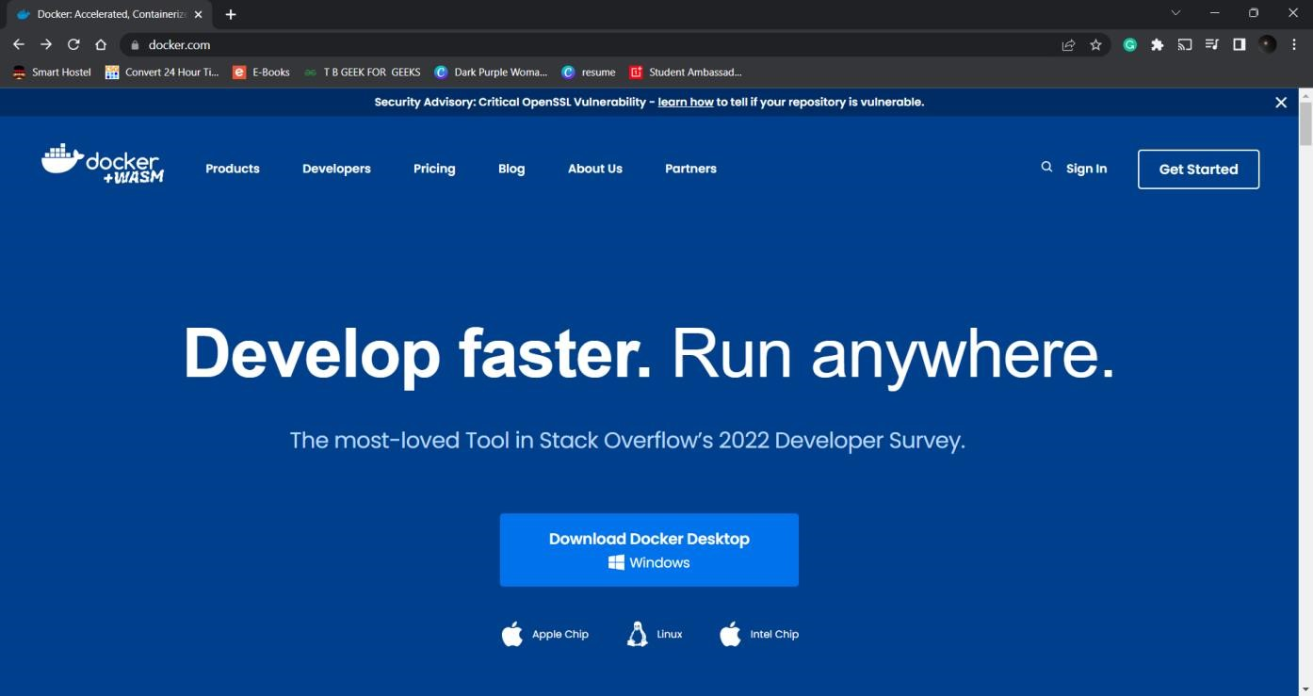

**Step 2**: Goto hub.docker.com register and create an account and login with the same.

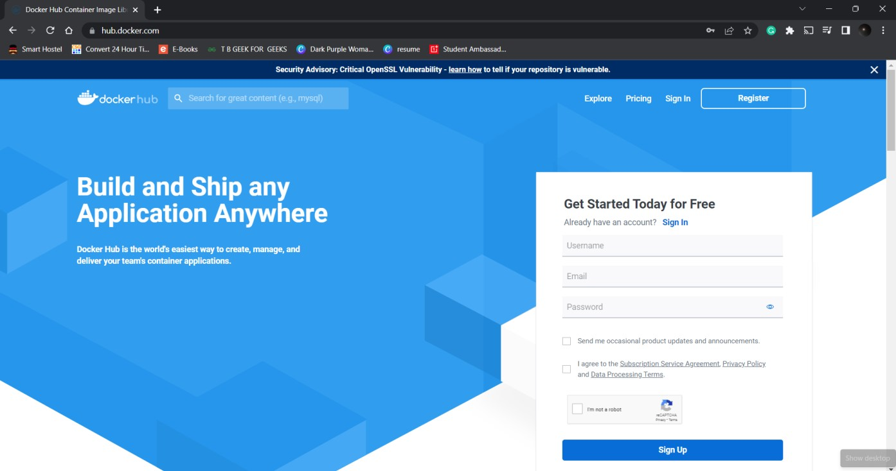

# NEWS TRACKER APPLICATION TEAM ID: PNT2022TMID49399

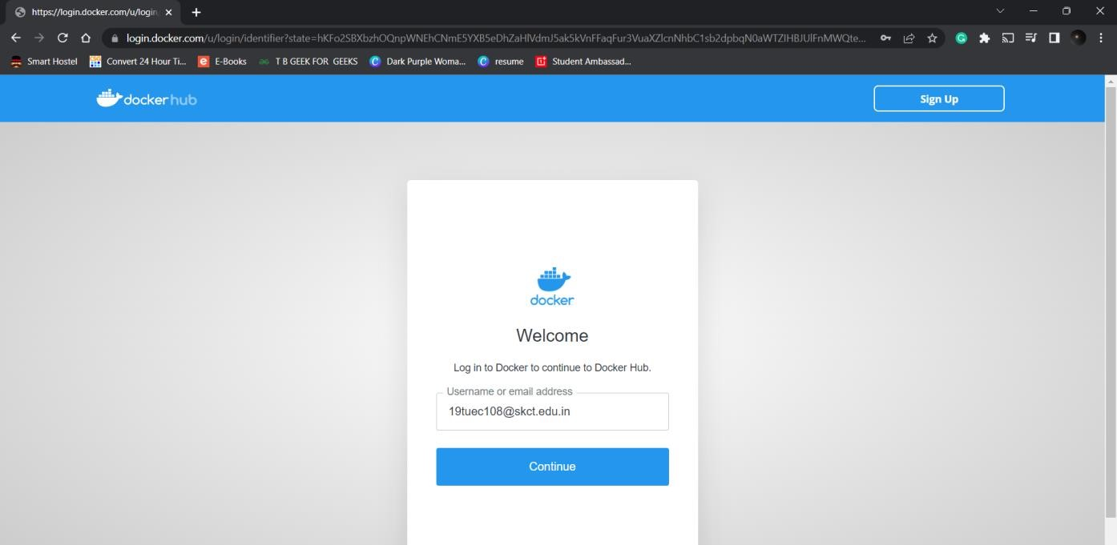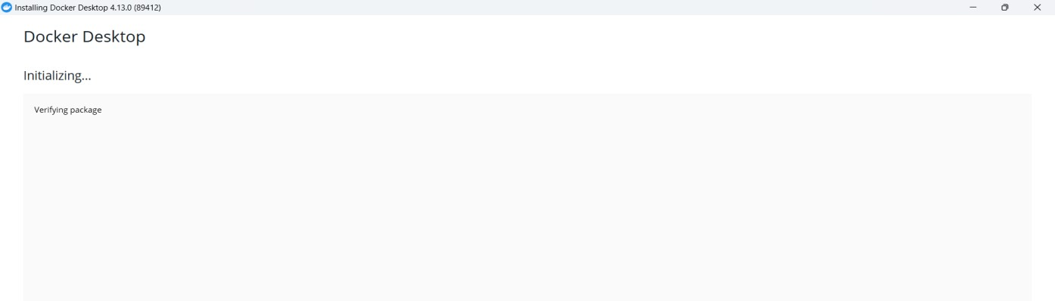

**STEP 3 :** Open Docker Desktop and start creating containers and images.

